ONLY ONE QUESTION ON THIS PAGE

Question 1 :

What is ‘The Kodra’? - Poland

Answers : (write the correct answer in red)
- a multicoloured collage on a rectangular sheet of white paper

- a cut-out in the shape of a tree

- an embroidery

If necessary, ONE picture for the question :

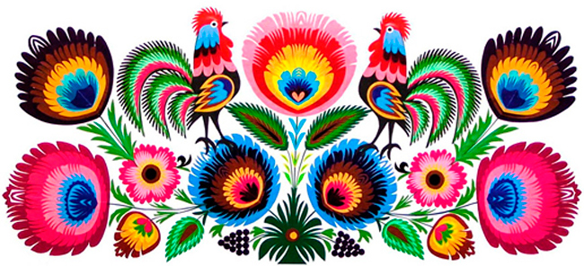

ONLY ONE QUESTION ON THIS PAGE

Question 2 :

In what Polish city is ‘The Kodra’ made ? - Poland

Answers : (write the correct answer in red)
- in Warsaw

- in Łowicz

- in Czarna

If necessary, ONE picture for the question :

ONLY ONE QUESTION ON THIS PAGE

Question 3 :

What patterns are characteristic for the Polish 'Kodra’? - Poland

Answers : (write the correct answer in red)

- flowers, roosters, the eyes of peacocks’ tail

- geometric figures

- lions and giraffes

If necessary, ONE picture for the question :
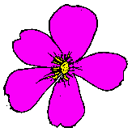
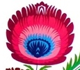
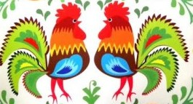
the eyes
of peacocks’ tail
roosters
flowers
ONLY ONE QUESTION ON THIS PAGE

Question 4 :

What is ‘The Leluja’? - Poland

Answers : (write the correct answer in red)
- a poster

- a drawing on glass

- a cut-out of one or many colours

If necessary, ONE picture for the question :
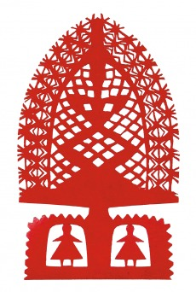
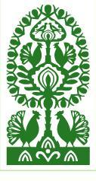

ONLY ONE QUESTION ON THIS PAGE

Question 5 :

What patterns are typical for the Polish 'Leluja’? - Poland

Answers : (write the correct answer in red)
- it is a star-shaped cut-out

- it is a circular cut-out

- it is a cut-out in a shape of a tree, coming from a vase

If necessary, ONE picture for the question :

ONLY ONE QUESTION ON THIS PAGE

Question 6 :

What Polish regions is the 'Leluja’ made in? - Poland

Answers : (write the correct answer in red)
A. in the mountains
B. in Kurpie and in Podkarpacie
C. by the sea

If necessary, ONE picture for the question :

ONLY ONE QUESTION ON THIS PAGE

Question 7 :

What Polish region is ‘The Star’ made in? - Poland

Answers : (write the correct answer in red)
- in Śląsk

- in Kurpie

- in Wielkopolska

If necessary, ONE picture for the question :

ONLY ONE QUESTION ON THIS PAGE

Question 8 :

What type of artistic form is the Polish 'Star? - Poland

Answers : (write the correct answer in red)
- it is a multicolour picture

- it is a cut-out in the shape of a circle, in one or two colours, with spokes branching out from the center

- it is a blue collage

If necessary, ONE picture for the question :

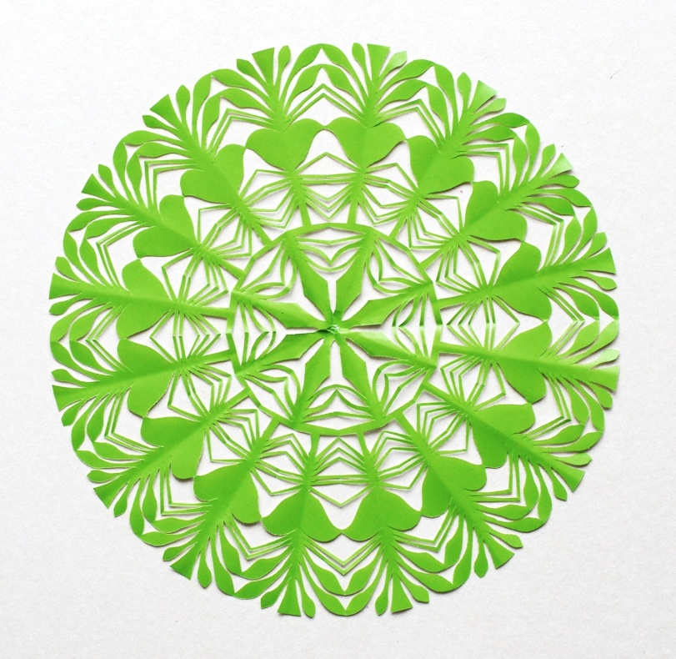

ONLY ONE QUESTION ON THIS PAGE

Question 9 :

What are the basic colours in the Polish Kaszubian’s pattern? - Poland

Answers : (write the correct answer in red)
- blue, black, red, yellow, green

- orange and purple

- brown and gold

If necessary, ONE picture for the question :

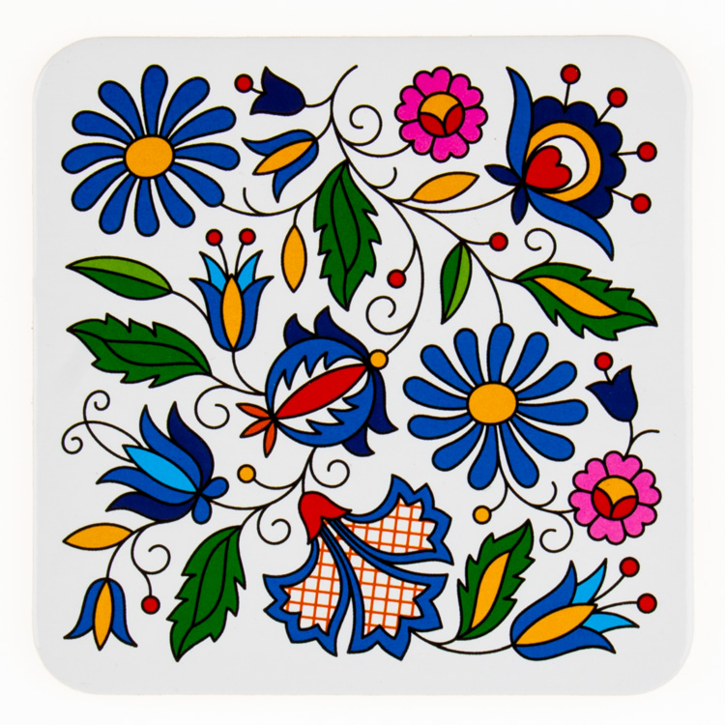

ONLY ONE QUESTION ON THIS PAGE

Question 10 :

What is ‘The Parzenica’? - Poland

Answers : (write the correct answer in red)
- it is a pattern in the shape of a flower

- it is a pattern in the shape of a maze
C. it is a pattern in the shape of a heart, typical for Polish mountain folk design

If necessary, ONE picture for the question :
